## CHAPTER 1

## INTRODUCTION

KeyGuardian is an innovative command-line tool engineered to enhance digital security through personalized encryption, precise decryption, and secure data handling. In today's climate of increasing data breaches and cyber threats, robust security measures are more critical than ever. KeyGuardian equips users with essential tools to effectively protect their digital assets, addressing the shortcomings of conventional key management systems. KeyGuardian differentiates itself by offering a comprehensive solution for cryptographic key management, ensuring keys are stored and managed securely. By utilizing advanced encryption techniques, strong access control mechanisms, and a decentralized storage infrastructure, it strengthens cryptographic infrastructures against unauthorized access and misuse [1]. This ensures that sensitive information remains safeguarded, even in the face of sophisticated cyber threats. A key feature of KeyGuardian is its ability to identify various hash algorithms. This functionality allows users to analyze and understand the type of hashing used in their data, providing insights into existing security measures.

Additionally, KeyGuardian includes a Hashify option, enabling users to convert plain text into multiple hash formats, which is particularly useful for securing passwords and other

sensitive information. The tool excels in the encryption and decryption of files and folders. With the Encrypt Files/Folder option, users can encrypt their data and generate appropriate keys, which are securely stored in a default folder named FKeys. The corresponding Decrypt Files/Folder option allows users to decrypt their data using a provided key or by automatically selecting the appropriate key from the FKeys folder if available. This seamless integration of encryption and decryption processes ensures data remains protected throughout its lifecycle. KeyGuardian’s architecture is designed to be versatile and scalable, making it suitable for a wide range of environments. Whether used by individuals seeking to protect personal data or by organizations aiming to secure corporate information, KeyGuardian adapts to various security needs. Its implementation balances user-friendliness with robust security, making advanced encryption accessible to users with different levels of technical expertise. In summary, KeyGuardian is a powerful command-line tool that significantly enhances digital security through personalized encryption, precise decryption, and secure data handling. By addressing the limitations of traditional key management systems and utilizing advanced cryptographic techniques, KeyGuardian sets a new standard for data protection. Its versatile and scalable architecture ensures it can meet the security demands of diverse environments, paving the way for a more resilient cybersecurity landscape [2,3].

##### Problem Statement

In the ever-evolving landscape of cybersecurity, the secure management of cryptographic keys remains a persistent challenge. Traditional key management systems often fall short, plagued by fragmentation, susceptibility to human error, and a lack of robust security measures. Recognizing the critical need for a centralized and sophisticated solution, KeyGuardian emerges as a pioneering platform designed to revolutionize encryption data management. By offering a cutting-edge approach to key management, KeyGuardian addresses the vulnerabilities inherent in traditional systems, providing users with a reliable and secure means of safeguarding their cryptographic keys. Through its centralized architecture and comprehensive security features, KeyGuardian empowers users to mitigate risks effectively while ensuring the integrity and confidentiality of their encrypted data. By bridging the gap between security needs and technological advancements, KeyGuardian sets a new standard for cryptographic key management, paving the way for a safer and more resilient cybersecurity landscape.

##### Objective

The objective of KeyGuardian is to streamline the encryption and decryption process by providing a user-friendly interface for managing cryptographic keys and performing cryptographic operations. Here's a sample objective statement for KeyGuardian: "Objective: Develop and deploy KeyGuardian, a versatile cryptographic tool, to simplify key management and cryptographic operations for users. KeyGuardian aims to provide a seamless experience for encrypting and decrypting data while ensuring the security and integrity of cryptographic keys. The tool should offer a default key folder feature for easy key storage and retrieval, as well as integrate various cryptographic functionalities, such as hash identification and encryption, into a unified platform. Additionally, KeyGuardian should prioritize user convenience and security, offering intuitive controls and robust encryption algorithms to meet the diverse needs of users.

###### Scope

The scope of the KeyGuardian project is extensive, encompassing various aspects related to data encryption, decryption, and key management. Here is an outline of the potential scope for the KeyGuardian project:

1. Encryption and Decryption Operations:

Implement algorithms for encrypting and decrypting data using cryptographic techniques. Support a wide range of file formats and data types for encryption and decryption operations.

2. Key Management:

Introduce a default key folder feature for secure storage and management of cryptographic keys. Enable users to generate, store, and retrieve keys conveniently within the KeyGuardian platform.

3. Integration of Cryptographic Tools:

Merge multiple cryptographic tools, such as hash identification and hash generation, into a unified platform. Provide seamless integration of these tools within the KeyGuardian interface for enhanced user experience.

4. Security Enhancement:

Implement robust security measures to ensure the confidentiality and integrity of encrypted data. Employ advanced encryption techniques to protect against unauthorized access and data breaches.

5. User Interface and Experience:

Design a user-friendly option-menu interface that simplifies hash identification, creating hashes, encryption, and decryption tasks.

6. Performance Optimization:

Optimize encryption and decryption algorithms for efficient resource utilization and faster processing speeds. Conduct performance testing to identify bottlenecks and areas for improvement in cryptographic operations.

7. Documentation and Support:

Generate comprehensive documentation outlining the functionalities and usage guidelines of KeyGuardian. Offer technical support and assistance to users for troubleshooting and resolving issues related to KeyGuardian.

##### Existing Software

*Traditional Key Management Systems:* Conventional systems often rely on manual processes for key management, leading to complexities, inefficiencies, and potential security vulnerabilities.

*hashID:* Kali Linux introduces hashID as a powerful alternative. This Python-based tool streamlines the hashing process, HashID has the ability to recognize over 175 unique hash types. Simply provide the hash, and HashID will identify its type.  
*CyberChef:* It is a versatile online tool that facilitates the encryption and decryption of data using various algorithms, with the added convenience of an offline version. Beyond its encryption capabilities, CyberChef offers functionalities such as defanging URLs, identifying RegEx patterns, and performing a myriad of other tasks, rendering it an invaluable resource for cybersecurity enthusiasts and professionals. Its multifaceted features make it a comprehensive and indispensable tool for handling diverse cybersecurity challenges with efficiency and ease.

##### Background and related work

###### TABLE 1.1. Comparison of various methodology suggested by authors

|  |  |  |  |  |
| --- | --- | --- | --- | --- |
| S. No. | Paper Name | Author | Year | Methodology |
| 1 | “Cloud Storage Security using Firebase and Fernet  Encryption” | Dhruv Sharma, C. Fancy | 2022 | This research explores cloud security as traditional networks move to virtualized environments. It analyzes security mechanisms for Infrastructure (IaaS), Platform (PaaS), and Software (SaaS) cloud services. The study emphasizes encryption (DES, AES, RSA, Blowfish) for data protection and proposes additional encryption to address the growing problem of cloud data breaches. |
| 2 | "Fernet Symmetric Encryption method to  gather MQTT E2E secure communications for  IOT Devices" | El Gaabouri Ismail, Chahboun Asaad, and Raissouni Naoufal | 2020 | This research tackles securing communication between devices in the Internet of Things (IoT). It highlights the vulnerability of MQTT's unencrypted messages and proposes Fernet, a lightweight encryption method, as a solution for resource-constrained IoT devices. |
| 3 | "Architectural Design of Representational State Transfer Application Programming Interface with Application-Level Base64-Encoding and Zlib Data Compression" | Aryo Pinanditoa, Agi Putra Kharismab, Eriq Muhammad Adams Jonemarob | 2023 | This study examines how compressing data with Zlib and Base64 encoding improves RESTful API performance, especially for mobile apps on limited data plans. It analyzes the trade-off between reduced bandwidth usage (up to 66%!) and the minimal overhead of compression/decompression. The results suggest data compression can significantly speed up RESTful API performance. |
| 4 | “Improving Data Embedding Capacity in LSB Steganography Utilizing LSB2 and Zlib Compression” | Joshua Calvin Kurniawan,Adhitya Nugraha,  Ariel Immanuel Prayogo, The Fandy Novanto | 2024 | Steganography gets a boost! This research improves data hiding in images by using a modified LSB method with Zlib compression. They can hide 36.54% more data while keeping image quality high. |
| 5 | “The Next Frontier of Security: Homomorphic Encryption in Action” | Prof. Shweta Sabnis, Prof. Pavan Mitragotri | 2024 | This study analyzes homomorphic encryption (PHE, SHE, FHE) for cloud security. It helps users pick the right encryption method for their cloud data, balancing security and performance. This research improves cloud data privacy and opens doors for secure data processing in the future. |
| 6 | “Research on Various Cryptography Techniques” | Bharati A. Patil, Prajakta R. Toke, Sharyu S. Naiknavare | 2024 | This research emphasizes cryptography's role in data security. It highlights key cryptographic goals like authentication, confidentiality, data integrity, and non-repudiation. The study also explores symmetric and asymmetric encryption algorithms. Overall, cryptography plays a vital role in securing data transmission and digital transactions. |
| 7 | “A Fernet Based Lightweight Cryptography Adopted Enhancing Certificate Validation through Blockchain Technology” | K. Obulesh, R. Laxmi Prasana,  S. Lakshmi Supraja, Sameena Begum | 2024 | This research tackles fake certificates with a blockchain solution. Traditional methods are slow, prone to error, and easy to tamper with. This new system uses blockchain and the Fernet-LWC algorithm to create a secure, transparent, and efficient way to validate certificates. |
| 8 | “Secure File Storage On Cloud Using Hybrid Cryptography” | AishwaryaNawal,  Harish Soni, Shweta Arewar,  Varshita Gangadhara | 2021 | This study is about cryptography and steganography for enhanced protection. Cryptography scrambles data with algorithms like AES-GCM and Fernet, making it unreadable without a key. The research recommends a mix of these algorithms for strong security. Steganography (not mentioned in detail here) further hides the encrypted data for an extra layer of defense. |

CloudSec: Enhancing Cloud Computing Security Through Advanced Encryption, this research by Ismail Gaabouri, Asaad Chahboun, and Naoufal Raissouni delves into the security mechanisms of cloud computing, transitioning from a basic network to a virtualized environment supporting multiple operating systems. The study scrutinizes the three core cloud service categories—IAAS, PAAS, and SAAS—and underscores the critical role of encryption techniques in data protection. The methodology encompasses the analysis of service-level agreements for cloud security and the exploration of encryption algorithms such as DES, AES, RSA, and Blowfish to bolster data security. Addressing the escalating incidence of data breaches in the cloud, the research advocates for an additional layer of encryption to fortify the confidentiality of data.

CyberGuard, Michael Carter and Jessica Lee contribute to the field by focusing on a unified platform for cybersecurity enthusiasts and professionals. The project streamlines various cybersecurity processes using C++’s Crypto++ and OpenSSL for robust and efficient code. The methodology covers encryption, decryption, hash identification, and force-decryption attempts using wordlists, ensuring a high level of security in data management. Future enhancements may explore the integration of additional security tools and expanded compatibility.

Sentinel, AI-Driven Security for the Modern World, Emily Chen and Brian Taylor investigate the role of AI in cybersecurity, emphasizing the use of machine learning algorithms for pattern detection and anomaly identification. The project's success lies in providing a dynamic and scalable architecture for proactive threat mitigation. Compatibility across various devices and operating systems ensures adaptability to evolving cybersecurity threats. Future enhancements may involve refining machine learning models and incorporating real-time threat intelligence.

KeyGuardian: Strengthening Cybersecurity Foundations, KeyGuardian, our project, is positioned within this landscape by offering a comprehensive cybersecurity solution. Drawing inspiration from the methodologies discussed, KeyGuardian integrates encryption, proactive security features, and data/keys management tools. The utilization of Python and C++ ensures robust data security, and the platform's user-friendly interface aims to provide a reliable means for users to safeguard their digital identities. Future developments may involve exploring additional security measures and further refining machine learning integration for adaptive threat response.

# CHAPTER 2

**HARDWARE AND SOFTWARE REQUIREMENTS**

##### Hardware Requirement:

* + - CPU: Intel Pentium or above
    - RAM – 2 GB or higher
    - Disk – min. 256 GB GB or higher

##### 

##### Software and Technology Requirement:

* + - Operating System : Windows NT or above / Linux
    - IDE : Visual studio Code (not mandatory)

# CHAPTER 3

**SDLC METHODOLOGIES**

A software life cycle model (also termed process model) is a pictorial and diagrammatic representation of the software life cycle. A life cycle model represents all the methods required to make a software product transit through its life cycle stages. A life cycle model maps the various activities performed on a software product from its inception to retirement. Different life cycle models may plan the necessary development activities to phases in different ways. Thus, no element which life cycle model is followed; the essential activities are contained in all life cycle models though the action may be carried out in distinct orders in different life cycle models. During any life cycle stage, more than one activity may also be carried out.

##### SDLC Models

* + 1. **Waterfall Model**

The waterfall is a widely used SDLC model. The waterfall model is a continuous software development model in which development is seen as flowing steadily downwards (like a waterfall) through the steps of requirements analysis, design, implementation, testing (validation), integration, and maintenance. To begin, some certification techniques must be used at the end of each step to identify the end of one phase and the start of the next.

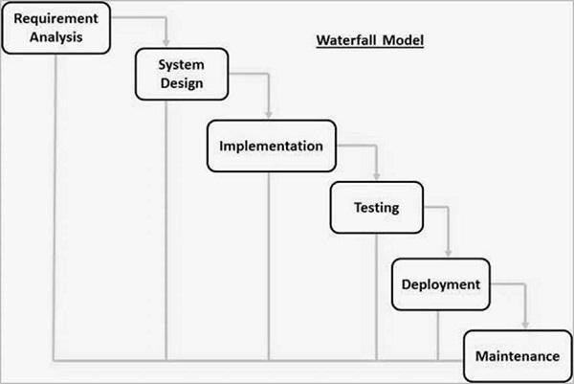

Figure 3.1. Waterfall Model

##### RAD Model

The Rapid Application Development (RAD) process is an adaptation of the waterfall model that aims to develop software in a short period of time. The RAD model is based on the idea that by using focus groups to gather system requirements, a better system can be developed in less time.

* + - * Business Modeling
      * Data Modeling
      * Process Modeling
      * Application Generation
      * Testing and Turnover

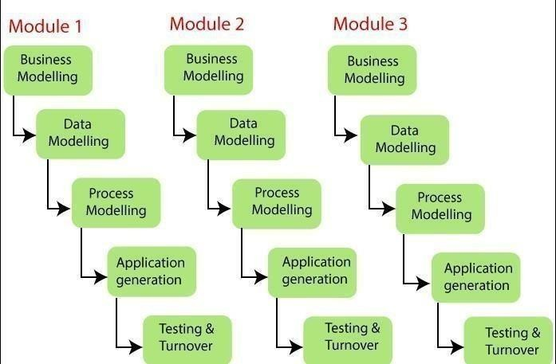

Figure 3.2. RAD Model

##### Spiral Model

The spiral model is a process model that is risk-driven. This SDLC model assists the group in implementing elements of one or more process models such as waterfall, incremental, waterfall, and so on. The spiral technique is a hybrid of rapid prototyping and concurrent designand development. Each spiral cycle begins with the identification of the cycle's objectives, the various alternatives for achieving the goals, and the constraints that exist. This is the cycle's first quadrant (upper-left quadrant).

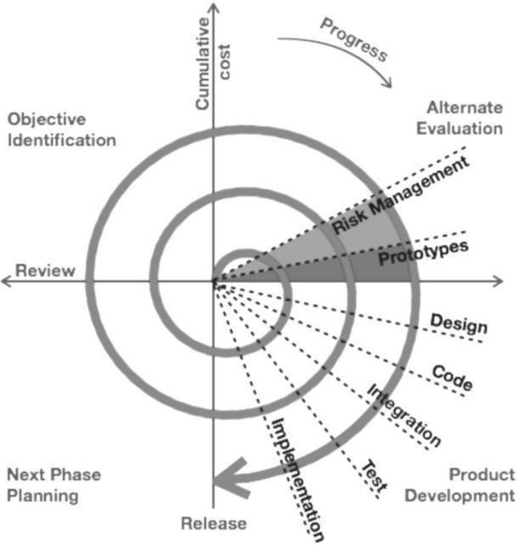

Figure 3.3. Spiral Model

##### Incremental Model

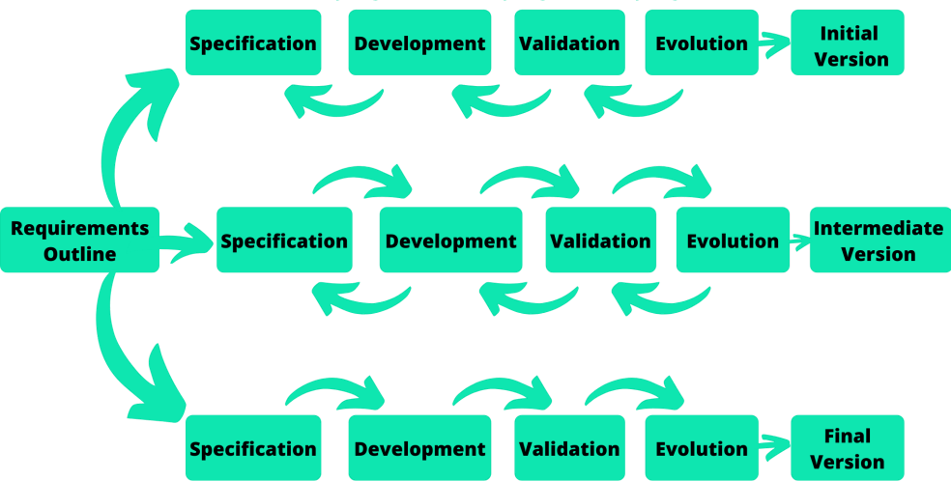The incremental model does not stand alone. It must be a series of waterfall cycles. At the startof the project, the requirements are divided into groups. The SDLC model is used to develop software for each group. The SDLC process is repeated, with each release introducing new features until all requirements are met. Each cycle in this method serves as the maintenance phase for the previous software release.

Figure 3.4. Incremental Mode

##### Model used in project: Prototype Model

* For our project we have used prototype model. The prototyping model starts with the requirements gathering. The developer and the user meet and define the purpose of the software, identify the needs, etc. A 'quick design' is then created. This design focuses on those aspects of the software that will be visible to the user. It then leads to the development of a prototype. The customer then checks the prototype, and any modifications or changes that are needed are made to the prototype. Looping takes place in this step, and better versions of the prototype are created. These are continuously shown to the user so that any new changes can be updated in the prototype. This process continue until the customer is satisfied with the system. Once a user is satisfied, the prototype is converted to the actual system with all considerations for quality and security.

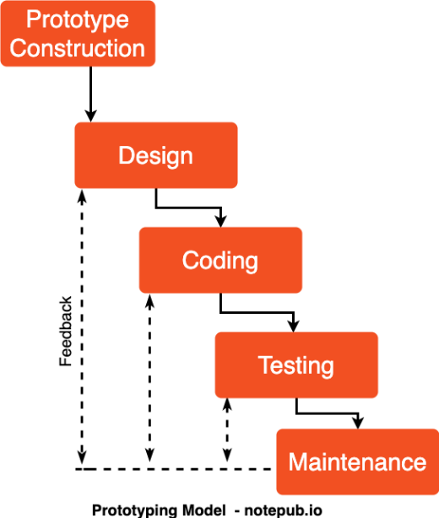

**Figure 3.5. Prototype Model (a)**

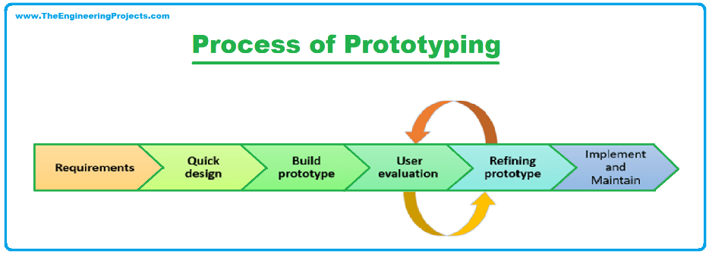

**Figure 3.7. Prototype Model (c)**

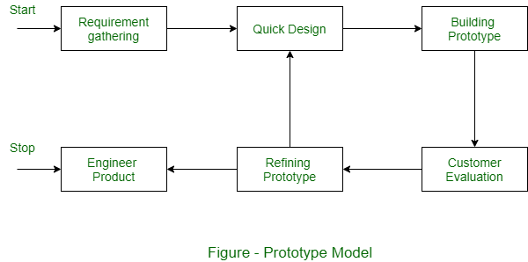

**Figure 3.6. Prototype Model (b)**

# CHAPTER 4

**SOFTWARE REQUIREMENT SPECIFICATION AND**

**ANALYSIS**

###### Purpose

The purpose of KeyGuardian is to provide users with a robust and user-friendly platform for managing cryptographic keys and performing encryption and decryption operations efficiently. It aims to streamline the process of key management and cryptographic operations, thereby enhancing data security and user experience.

###### Scope

KeyGuardian goes beyond traditional encryption tools by offering a comprehensive solution that addresses the complexities of key management. It includes features such as automatic key generation, secure storage of keys in a default key folder, and seamless integration with cryptographic algorithms. The scope of KeyGuardian encompasses key generation, encryption, decryption, and key management functionalities.

###### Definitions, Acronyms, and Abbreviations

SRS: Software Requirements Specification

UI: User Interface

API: Application Programming Interface

#### FUNCTIONAL REQUIREMENTS

###### Data File System Access

* + - * KeyGuardian should have the access to generate/modify cryptographic keys, encrypted and/or decrypted file.
      * KeyGuardian should randomize they keys to enhance the security and robustness.

###### Key Generation

* + - * KeyGuardian should have the capability to generate cryptographic keys securely.
      * The key generation process should adhere to industry standards for cryptographic key generation.

###### Encryption and Decryption

* + - * KeyGuardian must support encryption and decryption of files and folders using cryptographic keys.
      * It should employ robust encryption algorithms such as Fernet to ensure data security.

###### Key Management:

* + - * Users should be able to manage cryptographic keys efficiently, including storing, retrieving, and deleting keys.
      * KeyGuardian should provide a default key folder where users can securely store their keys.

###### User Authentication

* + - * KeyGuardian should include user authentication mechanisms to ensure that only authorized users can access the application.
      * Authentication methods may include username/password authentication or integration with third-party authentication providers.

#### NON-FUNCTIONAL REQUIREMENTS

###### Security

* + - * KeyGuardian should implement encryption for data transmission to ensure secure communication between the user's device and the application server like Google Cloud.
      * It should enforce access control mechanisms to prevent unauthorized access to cryptographic keys and sensitive data.

###### Performance

* + - * KeyGuardian should provide fast response times for key generation, encryption, and decryption operations.
      * It should be able to handle multiple concurrent users without compromising performance.

###### Usability

* + - * KeyGuardian should have a user-friendly interface that is easy to navigate and understand.
      * It should provide clear instructions and guidance to users on how to perform key management and cryptographic operations.

###### Reliability

* + - * KeyGuardian should be reliable and available whenever users need to perform key management or cryptographic operations.
      * It should have mechanisms in place to handle errors and exceptions gracefully, ensuring uninterrupted service.

###### Compatibility

* + - * KeyGuardian should be compatible with a wide range of operating systems and devices, including Windows, macOS, and Linux.
      * It should support integration with other software applications and systems through APIs or other interfaces.

###### Scalability

* + - * KeyGuardian should be designed to scale horizontally to accommodate an increasing number of users and data volumes.
      * It should be able to handle spikes in user activity without performance degradation.

#### DESIGN CONSTRAINTS

###### Technology Stack

* + - * Frontend: Python CUI
      * Backend: Python with Fernet framework
      * Database: SQLite

# CHAPTER 5

# RISK ASSESSMENT

#### PROJECT RISKS

###### Technical Complexity

Likelihood: High

Consequence: Delayed project timeline, increased development costs.

Risk Avoidance: Conduct thorough technology feasibility studies before project initiation.

Risk Reduction: Employ skilled developers with experience in the chosen technology stack.

###### Integration Challenges

Likelihood: Medium

Consequence: System malfunctions, data inconsistencies.

Risk Avoidance: Conduct comprehensive testing during integration phases.

Risk Reduction: Use standardized data exchange formats and protocols.

###### User Adoption

Likelihood: Medium

Risk Avoidance: Conduct user feedback sessions during development.

Risk Reduction: Implement an intuitive user interface, provide user training materials.

#### SECURITY AND COMPLIANCE RISKS

###### Data Breach

Likelihood: Medium

Consequence: Compromised user data, legal penalties, damage to reputation.

Risk Avoidance: Implement strong encryption standards for data storage and transmission.

Risk Reduction: Regular security audits and penetration testing to identify and address vulnerabilities.

###### Regulatory Compliance Violation

Likelihood: Medium

Consequence: Legal penalties, damage to reputation.

Risk Avoidance: Ensure compliance with relevant regulations like GDPR.

Risk Reduction: Regularly update security policies and procedures to align with regulatory changes.

#### OPERATIONAL RISKS

###### Downtime

Likelihood: Medium

Consequence: Disrupted services, user frustration.

Risk Avoidance: Implement redundant server infrastructure.

Risk Reduction: Regular maintenance during low usage periods.

###### Insufficient Scalability

Likelihood: High

Consequence: Poor system performance, frustrated users.

Risk Avoidance: Conduct scalability testing during development

Risk Reduction: Implement elastic scaling solutions.

#### EXTERNAL RISKS

###### Regulatory Changes

Likelihood: Low

Consequence: Changes in compliance requirements, project delays.

Risk Avoidance: Stay informed about healthcare regulations.

Risk Transfer: Regularly consult legal experts for compliance updates.

###### Third-Party Service Reliability

Likelihood: Medium

Consequence: Service interruptions, impact on functionality.

Risk Avoidance: Select reputable third-party services.

Risk Reduction: Implement fallback mechanisms for critical functionalities.

###### Market Competition

Likelihood: Medium

Consequence: Reduced market share, potential loss of users.

Risk Avoidance: Conduct thorough market research and competitive analysis.

Risk Reduction: Continuously innovate and improve KeyGuardian’s features to maintain a competitive edge.

#### RISK MITIGATION STRATEGIES

###### Risk Mitigation Planning

Risk Avoidance: Identify and eliminate risks at the early stages of project planning.

Risk Transfer: Utilize insurance and legal mechanisms to transfer specific risks.

Risk Reduction: Implement measures to minimize the impact or likelihood of identified risks.

###### Continuous Monitoring and Evaluation

Establish regular risk assessment reviews throughout the project lifecycle. Monitor external factors, such as changes in regulations, and adjust risk strategies accordingly.

###### Contingency Planning

Develop contingency plans for high-impact risks, ensuring swift responses to mitigate consequences.

Maintain a comprehensive disaster recovery plan in case of major system failures.

## **CHAPTER 6**

## **DATA FLOW DIAGRAM**

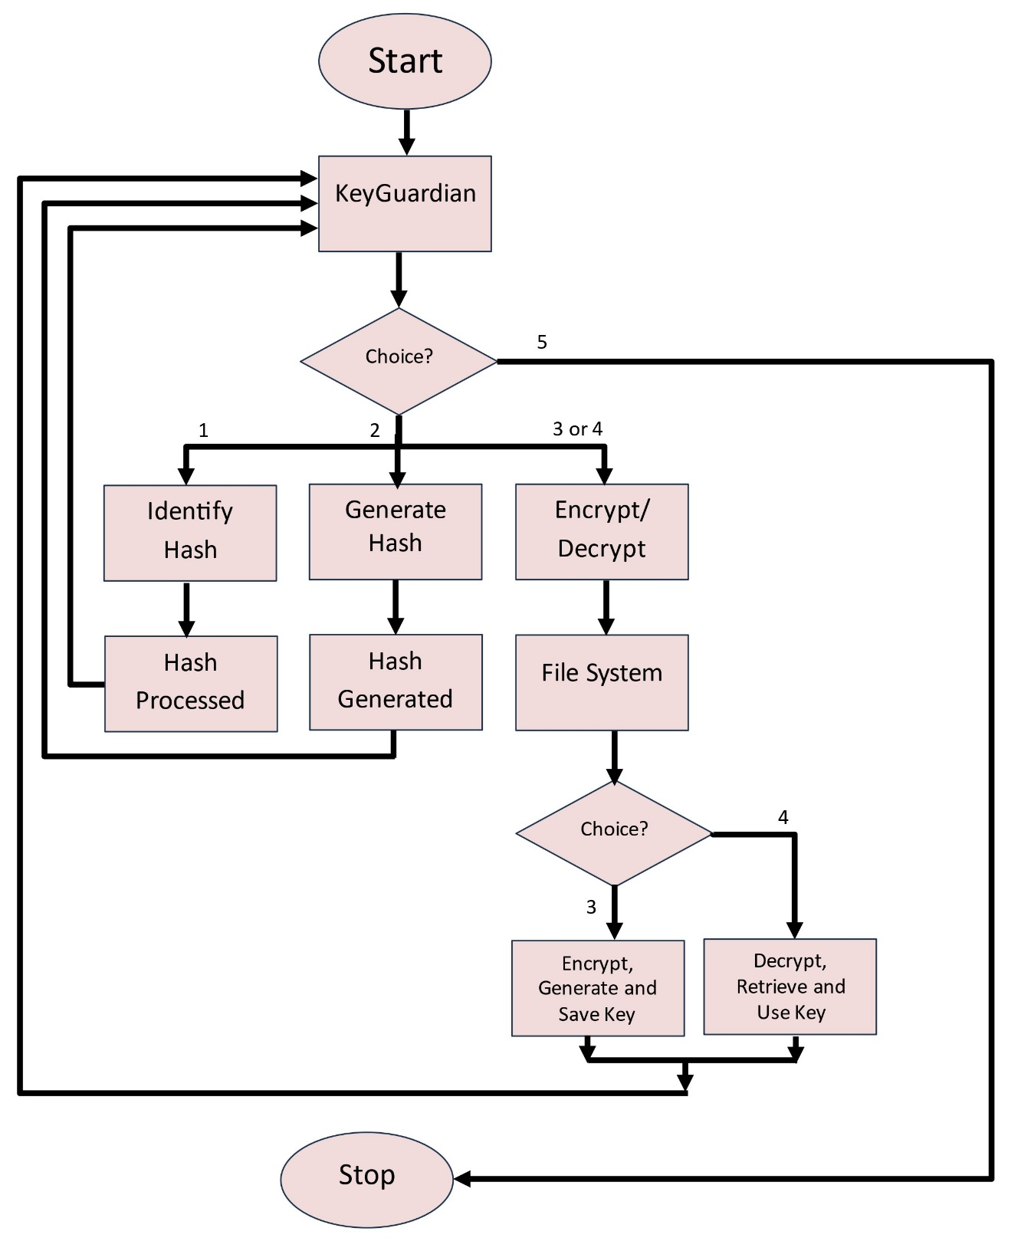

Fig. 6.1

## **CHAPTER 7**

## **SOFTWARE FEATURES**

* Encryption and Decryption: Provide robust encryption and decryption capabilities using advanced algorithms to secure user data.
* Key Management: Automatically manage cryptographic keys with a default key folder, simplifying the key handling process for users.
* Hashing Functions: Implement various hashing algorithms (e.g., SHA-256, MD5) for data integrity verification and other cryptographic purposes.
* Compression Support: Integrate zlib for data compression, allowing users to efficiently compress and decompress data files.
* Integrated Python Environment: Offer an embedded Python environment for users to execute their encryption, decryption, and hashing operations seamlessly.
* User-Friendly Command-Line Interface: Provide a comprehensive and intuitive command-line interface to facilitate easy interaction with KeyGuardian’s features.
* Multi-Algorithm Support: Support multiple encryption and hashing algorithms, giving users the flexibility to choose the most suitable method for their needs.
* Access Control: Implement role-based access control to ensure secure usage and management of cryptographic keys and data.
* Data Integrity Checks: Enable automatic integrity checks to verify the authenticity and consistency of data before and after processing.
* Real-Time Performance Metrics: Display detailed performance metrics for encryption, decryption, and hashing operations, including execution time and resource usage.
* Interactive Tutorials: Provide step-by-step tutorials and documentation to help users understand and effectively use KeyGuardian’s features.
* Cross-Platform Compatibility: Ensure KeyGuardian is compatible with various operating systems, including Windows, macOS, and Linux.
* Secure Storage Solutions: Offer options for secure, decentralized storage of encrypted data to protect against unauthorized access.
* Regular Updates and Support: Deliver regular updates to introduce new features, improve security, and provide technical support for users.
* Community Integration: Facilitate a user community for sharing best practices, tips, and collaborative problem-solving.
* Modular Design: Use a modular codebase to allow for easy future enhancements and the addition of new cryptographic algorithms.
* Automated Key Rotation: Include a feature for automatic key rotation to enhance security and minimize the risk of key compromise.
* Customizable Settings: Allow users to customize various settings, such as encryption parameters and key storage preferences, to fit their specific requirements.
* Audit Logging: Implement audit logging to track user actions and operations within the tool for security and accountability purposes.
* Mobile Compatibility: Ensure the interface is responsive and usable on mobile devices, enabling users to manage their cryptographic tasks on the go.
* Integration with Existing Tools: Support integration with existing tools and workflows to streamline the use of KeyGuardian in diverse environments.
* Offline Functionality: Provide offline functionality to enable users to perform encryption and decryption tasks without an internet connection.
* Extensive Documentation: Offer comprehensive documentation covering all features, usage guidelines, and troubleshooting tips.
* Multi-Language Support: Support multiple languages in the interface to cater to a global user base.
* Version Control for Keys: Include version control for cryptographic keys, allowing users to manage and revert key changes as needed.
* Security Audits: Conduct regular security audits and provide reports to ensure ongoing protection against emerging threats.

## **CHAPTER 9**

## **PROJECT SNAPSHOTS**

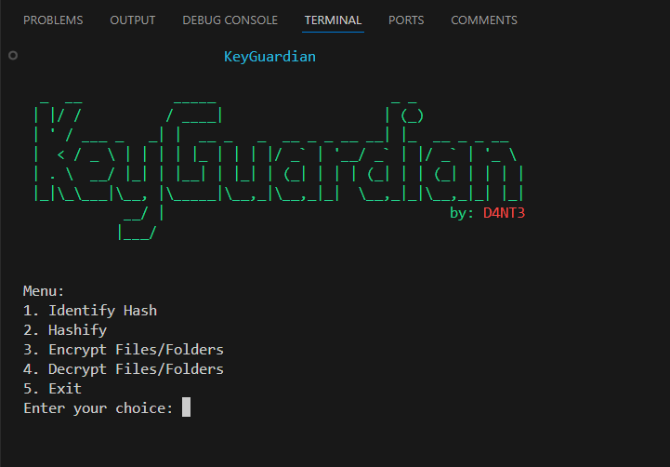

### 

### Fig 9.1 Main Menu

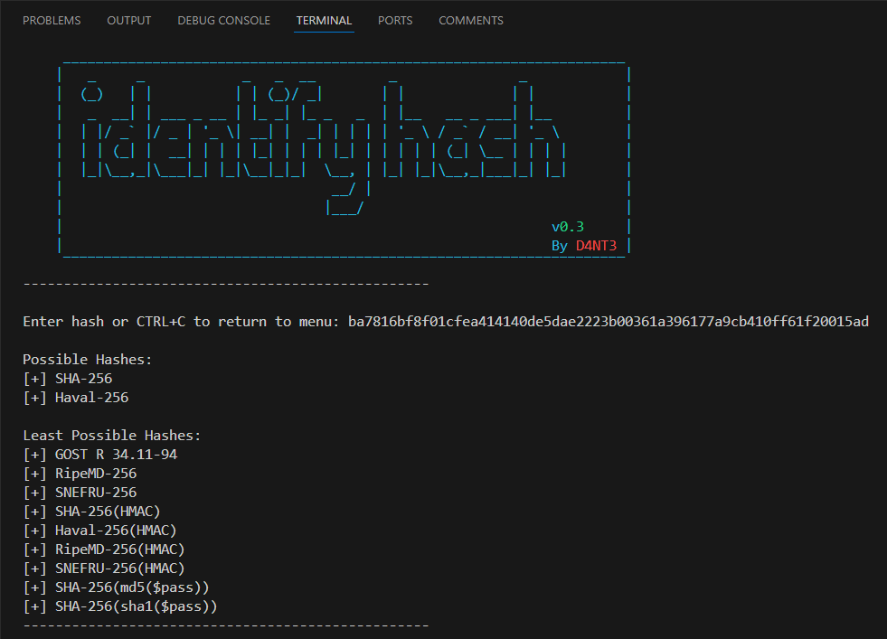

### Fig 9.2 Identify Hash Page

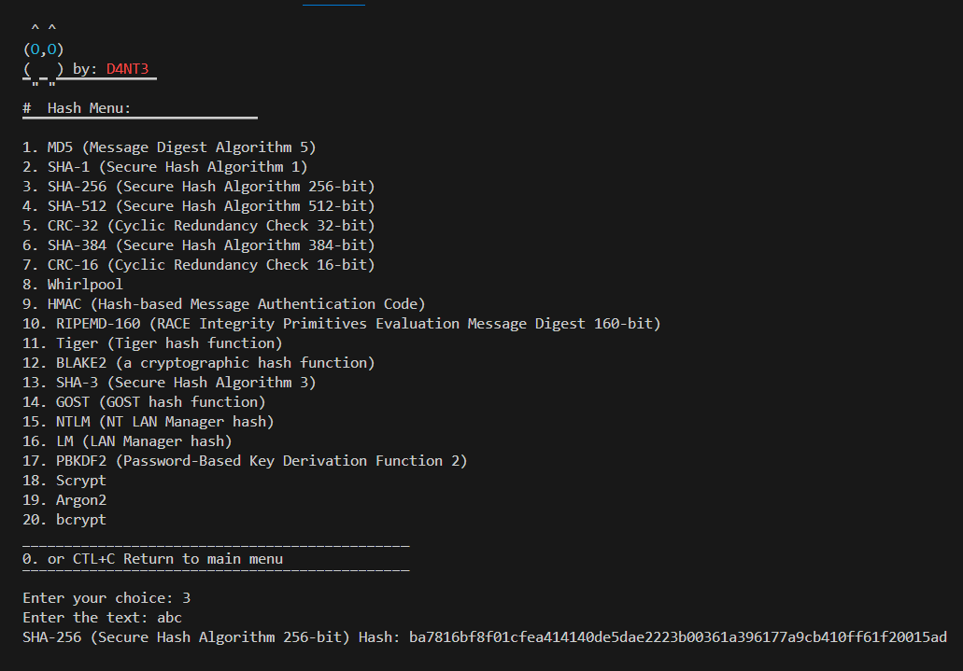

Fig 9.3 Create Hash Page

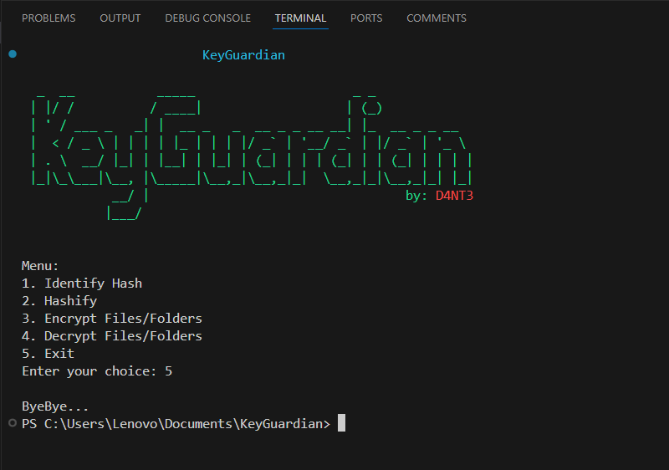

Fig 9.4Last option Exit

# References

[1] Dhruv Sharma, C. Fancy, (2022) "Cloud Storage Security using Firebase and Fernet Encryption," International Journal of Emerging Technologies (pp. 1-15). (<http://dx.doi.org/10.14445/22315381/IJETT-V70I9P237>)

[2] El Gaabouri Ismail, Chahboun Asaad, and Raissouni Naoufal, (2020) "Fernet Symmetric Encryption method to gather MQTT E2E secure communications for IOT Devices,". ResearchGate (pp. 1-20). (<https://www.researchgate.net/publication/349768295>)

[3] Aryo P. Pinanditoa, Agi Putra Kharismab, Eriq Muhammad Adams Jonemarob, (2023) "Architectural Design of Representational State Transfer Application Programming Interface

with Application-Level Base64-Encoding and Zlib Data Compression,". Journal of Information Technology and Computer Science (pp. 1-18). (<https://doi.org/10.25126/jitecs.202383619>)

[4] Joshua Calvin Kurniawan, Adhitya Nugraha, Ariel Immanuel Prayogo, The Fandy Novanto, (2024) "Improving Data Embedding Capacity in LSB Steganography Utilizing LSB2 and Zlib Compression", Sinkron: Jurnal dan Penelitian Teknik Informatika (pp. 1-17).

(<http://dx.doi.org/10.33395/sinkron.v9i1.13185>)

[5] Prof. Shweta Sabnis, Prof. Pavan Mitragotri, (2024) "The Next Frontier of Security: Homomorphic Encryption in Action," International Journal of Research in Advanced Engineering Sciences (pp. 1-14) .(<https://www.ijraset.com/best-journal/the-next-frontier-of-security-homomorphic-encryption-in-action>)

[6] Bharati A. Patil, Prajakta R. Toke, Sharyu S. Naiknavare, (2024) "Research on Various Cryptography Techniques," Computer Science & Engineering: An International Journal (pp. 1-16). ( <http://dx.doi.org/10.32628/CSEIT2410290>)

[7] K. Obulesh, R. Laxmi Prasana, S. Lakshmi Supraja, Sameena Begum, (2024) "A Fernet Based Lightweight Cryptography Adopted Enhancing Certificate Validation through Blockchain Technology," Journal of Software Testing (pp. 1-19). (<https://doi.org/10.46243/jst.2024.v9.i1.pp21-29>)

[8] Aishwarya Nawal, Harish Soni, Shweta Arewar, Varshita Gangadhara, (2021) "Secure File Storage On Cloud Using Hybrid Cryptography," International Journal of Advanced Research in Computer Science and Technology (pp. 1-15). (<https://doi.org/10.48175/IJARSCT-1101>)

[9] Singh, M., & Malik, A. (2024). Multi-hop routing protocol in SDN-Based wireless sensor network. In CRC Press eBooks (pp. 121–141). (<https://doi.org/10.1201/9781003432869-8>)

[10] Singh, M., Gupta, M., Sharma, A., Jain, P., & Aggarwal, P. (2023). Role of deep learning in the healthcare industry: Limitations, challenges, and future scope. In BENTHAM SCIENCE PUBLISHERS eBooks (pp. 1– 22). (<https://doi.org/10.2174/9789815080230123020003>)

[11] Gupta, M., Singh, M., Sharma, A., Sukhija, N., Aggarwal, P., & Jain, P. (2023). Unification of machine learning and blockchain technology in the healthcare industry. In Institution of Engineering and Technology eBooks (pp. 185–206). (<https://doi.org/10.1049/pbhe041e_ch6>)